**Lab Exercise 2**

Please answer the questions.

1.

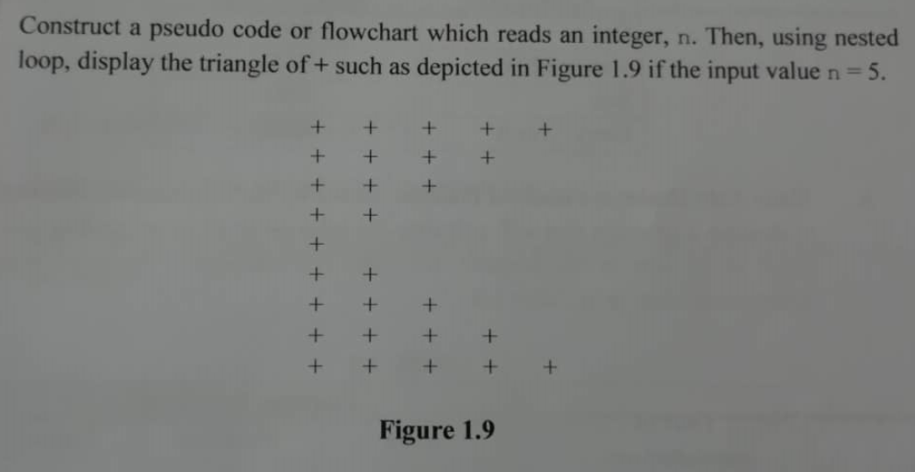

Pseudocode

1. Start
2. Set n=5
3. for n > 0 ? , n--
   1. for i=0, i<n ? ,i++
   2. Display “+”
   3. Print New line
4. for n<5 ? , n++
   1. for i=0, i<n ? ,i++
   2. Display “+”
   3. Print New line
5. End for
6. End

Top triangle bottom triangle

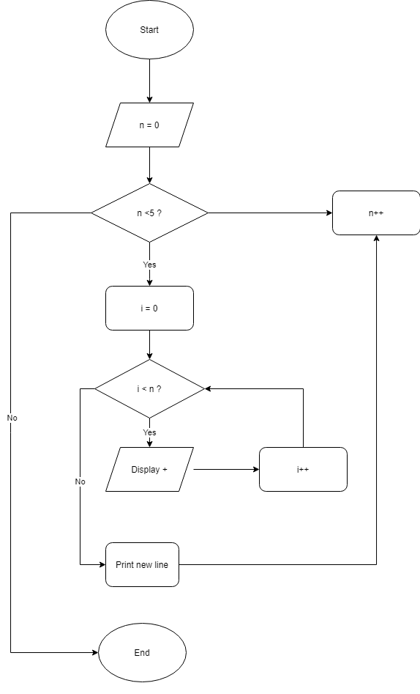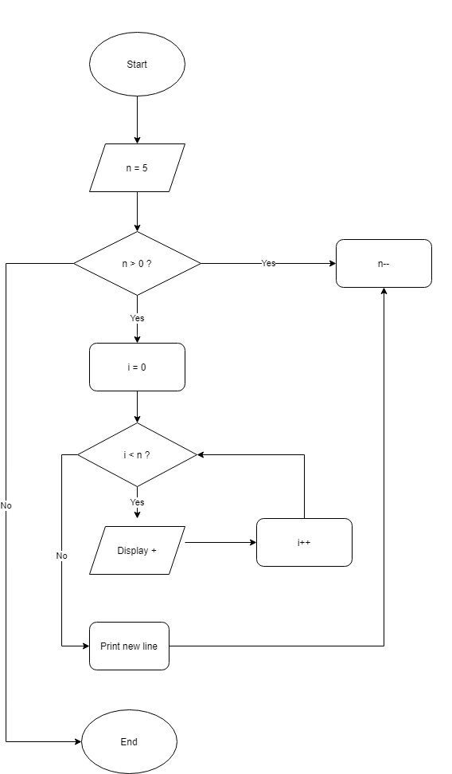

2.

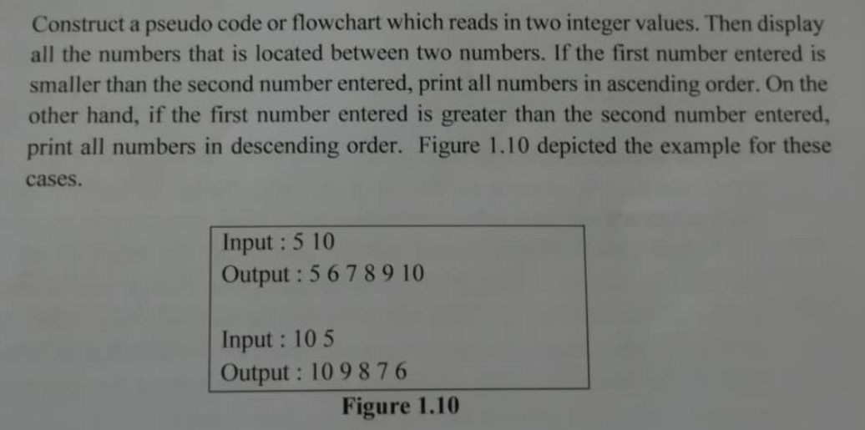

Don’t really understand how to answer this question Dr if need to use loops or arrays?

Pseudocode

1. Start
2. Read number1
3. Read number2
4. If number1== number2

4.1 Go to 9

1. If number1< number2
   1. Display number1
   2. number1 = number1 + 1
   3. Loop till go to 4
2. Else if number1> number2
   1. Display number2
   2. number2 = number2 -1
   3. Loop till go to 4
3. Else

Display “Invalid input!”

1. End if-else-if.
2. End